SUBASHREE.N-192521377
LAB EXPERIMENTS
EXP 14: TCL COMMANDS: COMMIT, SAVEPOINT, ROLLBACK
OUTPUT:
1:
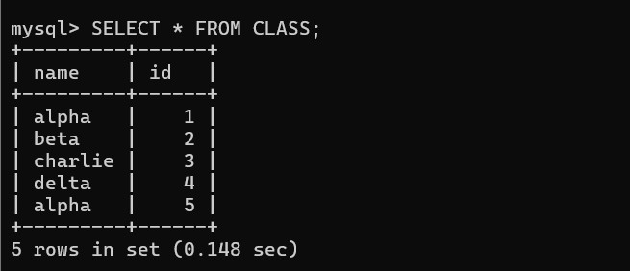
2:
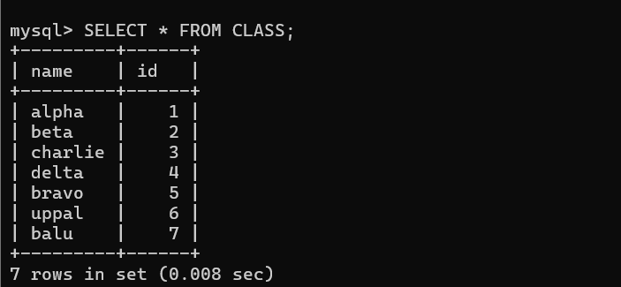
3:
